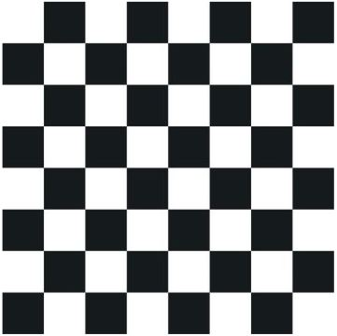**Twirl Effect Demonstration**:

Fig 5.4: Input image for Twirl effect

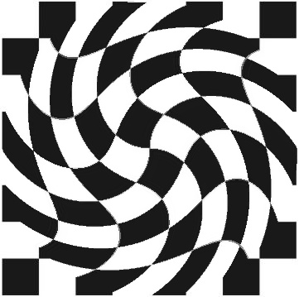

Fig 5.5: Output image for Twirl effect with Xc = W/2, Yc = H/2 and alpha = 90